Board Meeting Minutes December 17, 2019
Ideal Community Center
4:00 – 6:00 pm

Board Member Attendees: Steve Roe, John Forney, Llyoyd Thyen, Jim Chamberlin, Jim Brandt, Tom Kushel & Sheila Boldt.
Via Teleconference: Ron Meyer

(1) There was a motion Steve Roe seconded by Lloyd Thyen , to approve the 12/17/2019 agenda with the addition of (9) Back to Basics. Motion carried.
(2) There was a motion by Lloyd Thyen seconded by John Forney, to approve the 11/19/2019 Meeting Minutes. Motion carried.
(3) Committee Reports
- Finance
A. There was a motion by Steve Roe seconded by Ron Meyer, to approve $312.00 for payment to Auto Owners Insurance and $3,397.27. for payment to CW SWCD. Motion carried.
A. A lot of the recent membership donations have been roughly $100 and one large donation of which has been acknowledged (via a letter sent) by Ron.
D. Ron and Steve are going to discuss presenting an annual budget to the board for the year. They will convene and bring it to the board next year. One thing they want to budget for is a future grazing project with cover crops etc.
E. Discussion about whether The PRWA might ever hire either a part-time financial employee or an executive director. Discussion was that would cost approximately $30,000-$60,000 which is more than the organization can afford at this time.
- Membership
F. There was a motion by Steve Roe seconded by John Forney, to approve The PRWA official logo included in these minutes (to be printed color or black and white) as well as the letterhead attached within these minutes (below). Motion carried.
F. There was a motion by Steve Roe seconded by Lloyd Thyen, to approve business cards for current PRWA members upon request. Motion carried.
- Sheila has been asked to find out who would like them printed.
a. Lloyd
b. Clay?
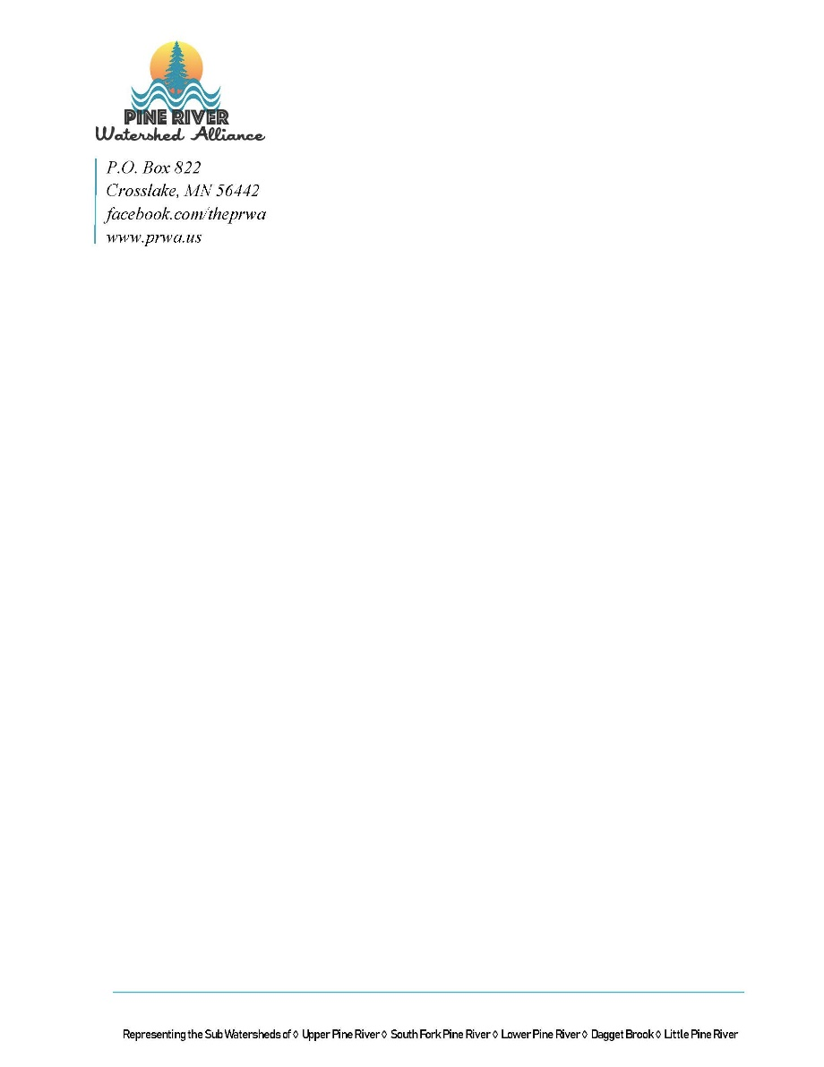
- Land and Waters
- Newsletter
A. Newsletters have been sent out and a comment at the meeting was made to confirm our current PRWA logo and be consistent with its use in envelopes and stationary.

- Website/Facebook
A. Updates to be added to the website (hoping to have complete by the end of January):
- One Watershed One Plan (1W1P)
- Upper Whitefish
- Arvig Cover Cropping project
- Grazing Management Project
E. Sheila will work with Tasha to update Meeting Minutes on PRWA website.
- Land and Ag
- Conservation/Enbridge
A. Thursday December 19th in Duluth at The Radisson is/was a meeting for Line 3 regarding the Lake Superior Watershed. They’ve requested more donations.
B. Steve discussed why Enbridge is not utilizing the stronger pipe (not made in the US and designed substandard) and thinks it’s because it’s going over mostly private (not public) land and therefore the laws and regulations might not apply.

(4) Upper Whitefish Project – Consultant
- Continuing to work with Dick Osgood , consultant to do a comprehensive plan and view all details about The Whitefish Chain.
- Impact zebra mussels are having on weed growth?
- Complete a weed inventory this summer.
- There is no accepted method to look at Zebra mussel density.
- Treatment techniques for removing the phosphorus.

(5) MASWCD Meeting
A. Ron Meyer attended the Awardee Luncheon on Minneapolis on December 10th. Good to hear all of the positive things going on around the state of MN, heavily farm-based (cover crops etc).
B. The Pine River 1W1P was highlighted at a business meeting that was completed quickly, efficiently and a good overall plan.

(6) CW Forage Basin Winter Meeting
There was a motion by Steve Roe seconded by Lloyd Thyen, to register The PRWA for The CW Forage Basin Winter Meeting with a Gold Sponsorship of $500, which includes 4 attendees as well as a table display. Motion carried.
- Sheila will set-up registration and include in a future invoice to PRWA from CW SWCD. The CW SWCD will be in charge of the booth set-up and attendance.

(7) FOH
There was a motion by Lloyd Thyen seconded by Steve Roe, to donate $5,000 to The Friends of The Headwaters by The PRWA from the restricted funds. Motion carried.
- Steve will follow-up with Richard with FOH and send the check.

(8) 1W1P – Grazing Management Project
A. Abe and Denny interviewed a number of landowners with cattle. 10-12 were chosen to move forward with better grazing practices and potentially cover crops. Abe and Denny’s next step is to consult with these producers on how to adjust their farm along with an NRCS resource person (cost-share assistance availability).

(9) Back to Basics Approval?
There was a motion by Steve Roe seconded by Tom Kushel, to approve registration up to $150 to The 2020 Back to Basics Event in Pine River. Motion carried.
- Gordy has registered us a table, lunches and Sheila is presenting.

(10) Board Comments
Tom – Good to have project ideas ready for when grant funds might have a surplus.
Jim – Another grandchild on the way.
Lloyd – Dive team trying to quantify early assessment of zebra mussels (quantifying the infestation). 1W1P identified a parcel for John Sumption at The Northern Waters Land Trust (formerly LLAWF) to look at.
Sheila – Need to update a new PRWA/CW SWCD contract and will be hiring a full time position in the office to assist in easement processing.
John – Congratulations to Ron on award at MASWCD, we should include this in communications to membership. Think appropriate to support FOH. Grant worth $315,000 Hwy 66, Crosslake city hall and moonlight square toward Stormwater improvement.
Ron – will be back up for a few days for the holiday, first time to have the whole family together.

Save the Date for the 14th Annual Back to Basics!

Saturday, February 15th, 2020

https://www.happydancingturtle.org/

2020 B2B Presenters Grid

Single 1 - 10:15-11:15 | Requests | Room # | Double 1 - 10:15-12:40 (Break 11:15-11:40) | Requests
S1. How to Garden as If Your Life Depended on It - Kathy Connell | 30 max, projector |  | D1. Make Your Own Cleaners & Lotions - Christine Jones, Michael Neumann, Kelsi Wills | Water
S2. Gentle Chair Yoga - Bryana Cook | 25 max, space for chairs |  | D2. Seven Steps to a Passionate Life - Michelle Oie | Whiteboard or Flip Chart
S3. All Things Elderberry - Allie Brandon | Projector, running water |  | D3. Intro to Meditation - Becky Stienhoff | Space to sit & walk
S4. Deep Winter Greenhouse Construction - Shayne Johnson | Projector |  | D4. Coffee 101: Home Roasting and the Perfect Cup - Martin Russo
S5. Seed Saving - Barbara Kaufman | FACS pref. - baking sheets, cutting boards; max 20
S6. Who's Got Your Back? Building an Informal Team - Larellyn Micheau, Theresa Eclov | Projector
S7. Basic Beekeeping - Tara Stang | Projector
S8. Intro to Electric Cars - Doug Weiss, Barb Mann | Projector
Single 2 - 11:40-12:40
S9. Garden Fertility - Kathy Connell | 30 max, Projector
S10. Gentle Yoga + Self-Massage - Bryana Cook | 12 max, cleared/clean space for mats
S11. Struggling with Marketing? Let's Make it Easy! - Casey Gromer | Projector
S12. Deep Winter Greenhouse Growing - Louise Johnson | Projector, Area to mix soil, seed flats, gutters
S13. National Loon Center - Kris Kristufek | Projector
S14. Healthy Eating Principles - Beth Noordmans | Projector
S15. Do Your Feet Hurt? - Stacey Quade, Joseph Quade
Single 3 - 1:00-2:00
S16. Home Energy Efficiency: Save Money & Reduce Your Environmental Impact - Melissa Birch | Projector
S17. Intro to T'ai Chi and Chi Kung - Dan Hegstad | Open room; chairs
S18. Pamela Broekemeier - Yes, You Can Eat the Weeds! | Projector
S19. Spring Knit Cowl - Esther Endicott | 8-10 max
S20. Indoor Agriculture - Jon Friesner | Projector
S21. Building the Foundation of a Multi-Sector Regenerative Supply-Chain - Regi Haslett-Marroquin | Projector
S22. The Labyrinth De-Mystified - Barb Mann | Projector, 28x28 or 36x36 floor space
S23. Growing and Gardening Tips From... You! - Kent Scheer | Friendly/Circle seating; Whiteboard
Single 4 - 2:20-3:20 |  |  | Double 2 - 2:20-4:45 (Break 3:20-3:45)
S24. Clean Energy for Your Small Business or Farm - Melissa Birch | Projector |  | D4. Your Backyard, Your Legacy - Sheila Boldt, Eleanor Burkett | Projector, wall space or large tables; set for roundtable discussion
S25. Holistic Health Care for Your Pet - Dr. Deb Brown |  |  | D5. Artisian Sourdough: Bread Worthy of the Name "Staff of Life!" - Steven Dahlberg | Projector, Kitchen
S26. Traditional Chinese Medicine - Starr Jarvis |  |  | D6. Hydroponics Home & Business - Barry Thoele | Projector
S27. Berries in a Chaning Climate - Thaddeus McCamant | Projector
S28. Growing Microgreens & the Health Benefits Behind Them - Carka Mertz | Projector, Water
S29. Tips, Techniques, & Recipes for Dutch Oven Cooking - Tony Noordmans
S30. Our Woods Could Help - Kent Scheer | Whiteboard space
S31. Intro to Meridian Tapping - Becky Stienfhoff
Single 5 - 3:45-4:45
S32. Healing with the Earth - Laura Adrian | Space to lay down
S33. Meat 101 - Jim Chamberlin, Chris Glassmann | Projector
S34. The Power to Make a Difference with Solar Energy - Rachel Juritsch, Martha Risedorf | Projector
S35. Developing a Sense of Place Through Phenology - John Latimer | Projector
S36. Save Money. Save the Planet. - Kay Paulus | Projector
S37. Herbal Medicine 101 - Marina Povlitzki
S38. Mushroom Cultivation for the Home Gardener - Matt Ratliff | Projector
S39. Winter Tabletop Gardening - Mark Schultz | Projector

